**The Fear Conversation**

Psychological safety won’t entirely remove the fear of things going wrong, but it can reduce it. By creating a supportive atmosphere where people can voice their fears, you help them to rationalise them and, where appropriate, mitigate risks.

This exercise has one primary aim:

1. **To help people practise vulnerability and openness with respect to their fears.**

And one secondary aim:

1. **To establish simple ways to mitigate some of these “real” fears.**

Be aware that this exercise can surface some of the deeper fears that team members may possess, including but not limited to:

* Fear of being perceived as incompetent.
* Fear of being punished for failing.
* Fear of being fired for making a mistake.
* Fear of humiliation through showing emotion and vulnerability.
* Fear of not having the answers when asked a question.
* Fear of losing control.
* Fear of getting things wrong.
* Fear of letting people down.
* Fear of not being good enough.

It’s important that we normalise these fears - you can highlight to your team that these are fears that we all experience at times. This is not about judging our experiences, but instead creating a safe place in which to open up about them. That said, team members should be invited to share as much or as little as they feel comfortable with, and it’s important to thank individuals for anything they share however small. Vulnerability should never be forced, and for some even a seemingly minor act of sharing may take a great deal of courage.

Keep this exercise focused on fears that are specific to your team, your work, your industry and your domain. This will help team members to be more objective, and keep the narrative about their work rather than who they are as people, although of course personality traits and personal preferences will play a role.

**Running the Fear Conversation Exercise**

1. Use a large printed copy of the *Fear Chart* (item H) or draw your own on a whiteboard.

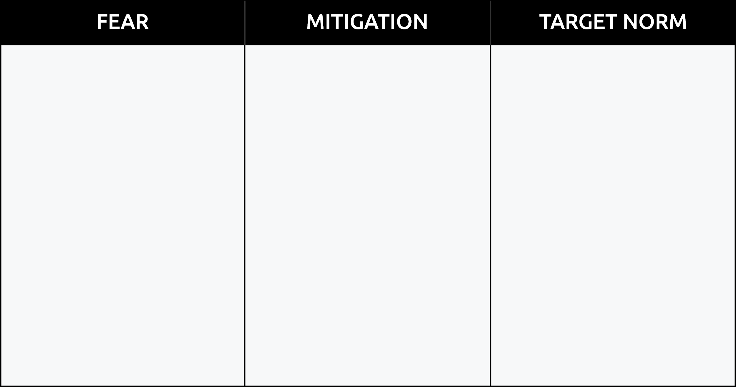

1. Initiate the discussion by writing on the chart one or two of your own fears, such as failing to hit targets or someone leaving the team. Ask everyone to share at least one work-related fear that they are experiencing currently. Write the fears onto the chart as you go. Thank each person for sharing and ask any clarifying questions. Continue until everyone has spoken at least once
2. Go through the fears one by one and ask for ideas from the whole team about how each fear may be mitigated. A single fear may have more than one mitigation. Add ideas to the middle column. An example ***Mitigation*** for a fear of missing a deadline might be *weekly check-ins with the stakeholders to ensure everyone is on track*. Some additional examples are in the exemplar chart at the end of this document.
3. Finally, discuss how the team’s “***Target Norm***” could be described. This is your team’s “happy place”, i.e. what it’s like in their ideal world. Over time, you and your team will work to get closer to this state. For example, the “***Target Norm***” might be: “*We know well in advance if a project is on-track, and can take appropriate action to deal with risks to meeting a deadline*.”
4. Invite team members to reflect on how they feel at the end of this exercise, and what changes they will make as a result of this mitigation planning.
5. Place the completed chart somewhere that everyone can see. Enable and encourage the team to implement as many of the mitigation strategies as possible.

Revisit this exercise as frequently as you wish. It is particularly powerful to carry out after periods of change, such as team members leaving, joining, teams restructuring, or after significant work periods or projects.

**Exemplar**:

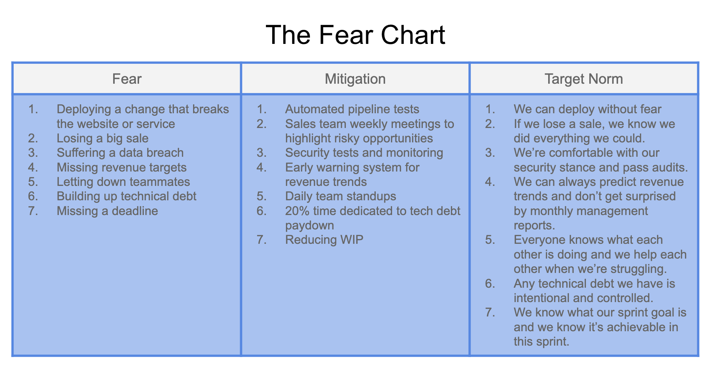

For further information, also see “Agile Conversations” by Douglas Squirrel and Jeffrey Fredrick.